ALUMNI PROGRAM
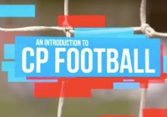

Weekly Training Sessions in
Meridian Junior College Football Field,
Every Friday 4.15 to 6.15pm
Trained by National Coach Khairul

The benefits of playing CP Football
Football has the power to bring people together and to break down barriers. It a great spectator sport that athletes with Cerebral Palsy get tremendous pleasure from taking part in.
- Improve their health by participating in a regular activity
- Participate in a team sport with other football players with similar abilities
- Learn team and individual CP Football skills
- Future opportunity to compete in a high sport level
