ALUMNI PROGRAM
MUSIC AND MOVEMENT
Weekly Sessions in CPAS
Every Wednesday 3 to 4 pm
Conducted by Teacher Dolph Oh
Certified Music Instructor, Flinders University, NTU
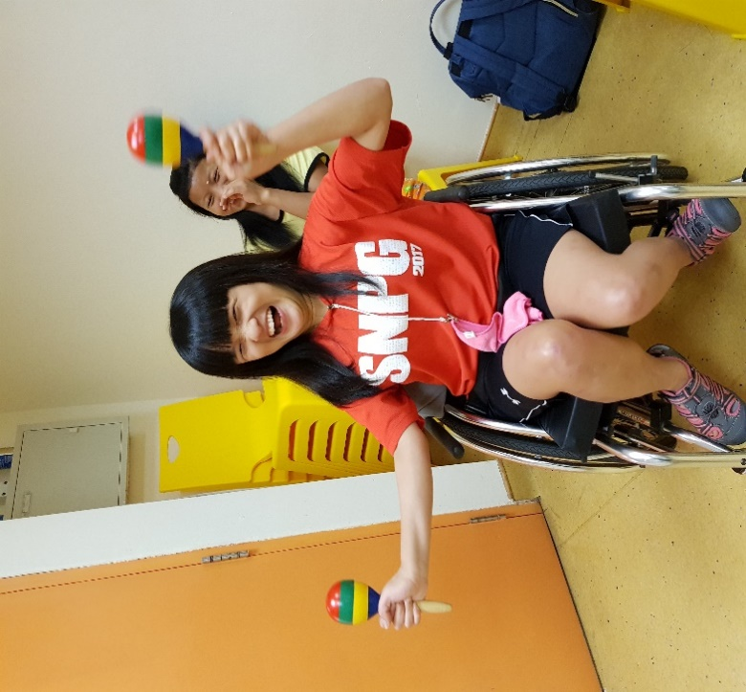
Music therapists use music to address developmental goals in the following areas:
- Speech and communication – Singing custom written songs, i.e. Big Bear Takes a Bubble Bath, to isolate speech sounds and get lots of repetition without monotony.
- Fine and gross motor – Using traditional and adaptive percussive instruments, like maracas, to address specific fine and gross motor skills.
- Academic – Putting academic information into a song format so that recall is improved.
- Social skill development – Music therapy groups where clients practice greetings, turn taking, eye contact, requesting, self-expression, collaboration, etc., through musical activities.
- Behavioral - Creating songs and musical stories about appropriate behavior.
- Social-Emotional – Using songs to teach a client how to identify feelings and use coping strategies when they are feeling overwhelmed

