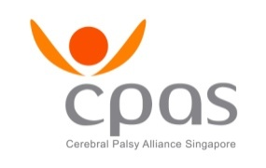

**TENDER NOTICE**

|  |  |
| --- | --- |
| **Quotation Ref. No.:** | ITT/LIFT/2025/0001 |
|  |  |
| **Publication Date:** | 12 June 2025 |
|  |  |
| **Description:** | INVITATION TO TENDER FOR UPGRADING OF LIFTS IN CEREBRAL PALSY ALLIANCE SINGAPORE (EAST) |
|  |  |
| **Closing Date and Time:** | 26 June 2025, 4 pm |
|  |  |
| **Amended Closing Date and Time:** | - |
|  |  |
| **Offer Validity Duration:** | Three (3) calendar months |
|  |  |
| **Tender Box No.:** | Cerebral Palsy Alliance Singapore  (Cerebral Palsy Centre, 65 Pasir Ris Drive 1, Singapore 519529)  Tender Box No. 1 |
|  |  |
| **Collection Method:** | The documents are available on CPAS website under “News & Events – Latest News” |
|  |  |
| **Contact Person:** | Mr Edrick Sum  DID: 6585 5767  Email: edrick_sum@cpas.org.sg |
|  |  |
| Cerebral Palsy Alliance Singapore (CPAS) does not bind itself to accept the lowest or any Offers and is not under any obligation to inform any Tenderer of the reasons for non-acceptance of an Offer. | |